
Mathematics Specialist
Test 4 2017

Integration Techniques &
Applications of Integral Calculus

NAME: _______________________________________________ TEACHER: Mrs Da Cruz

Resource Free Section

33 marks
35 minutes

Question 1 [3 & 3 = 6 marks]
- Express as partial fractions.

- Hence determine $\int_{2}^{8}{\frac{2}{x^{2}-1}dx}.$ Give your answer in the form $\ln{\frac{p}{q}}$.

Question 2 [3, 2 & 2 = 7 marks]
Determine the following indefinite integrals:
(a) $\int{1-\cos^{2}{(5x)} dx}$

-

(b) $\int{\frac{1}{2}\left(2x-4\right){\left(x^{2}-4x+1\right)}^{6}dx}$

(c) $\int{\sin^{3}\left(2x\right)\cos{(2x)} dx}$

Question 3 [5 marks]
Use the substitution $u=4+\sqrt{x}$ to evaluate $\int{\sqrt{4+\sqrt{x}} dx}$.
Do not factorize or simplify your answer.

Question 4 [1 mark]

The area under the curve y = k(x) can be described by:
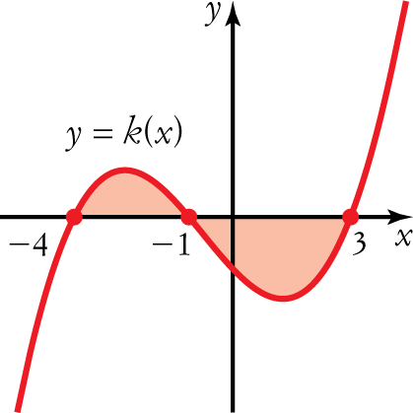
A
B
C
D
E

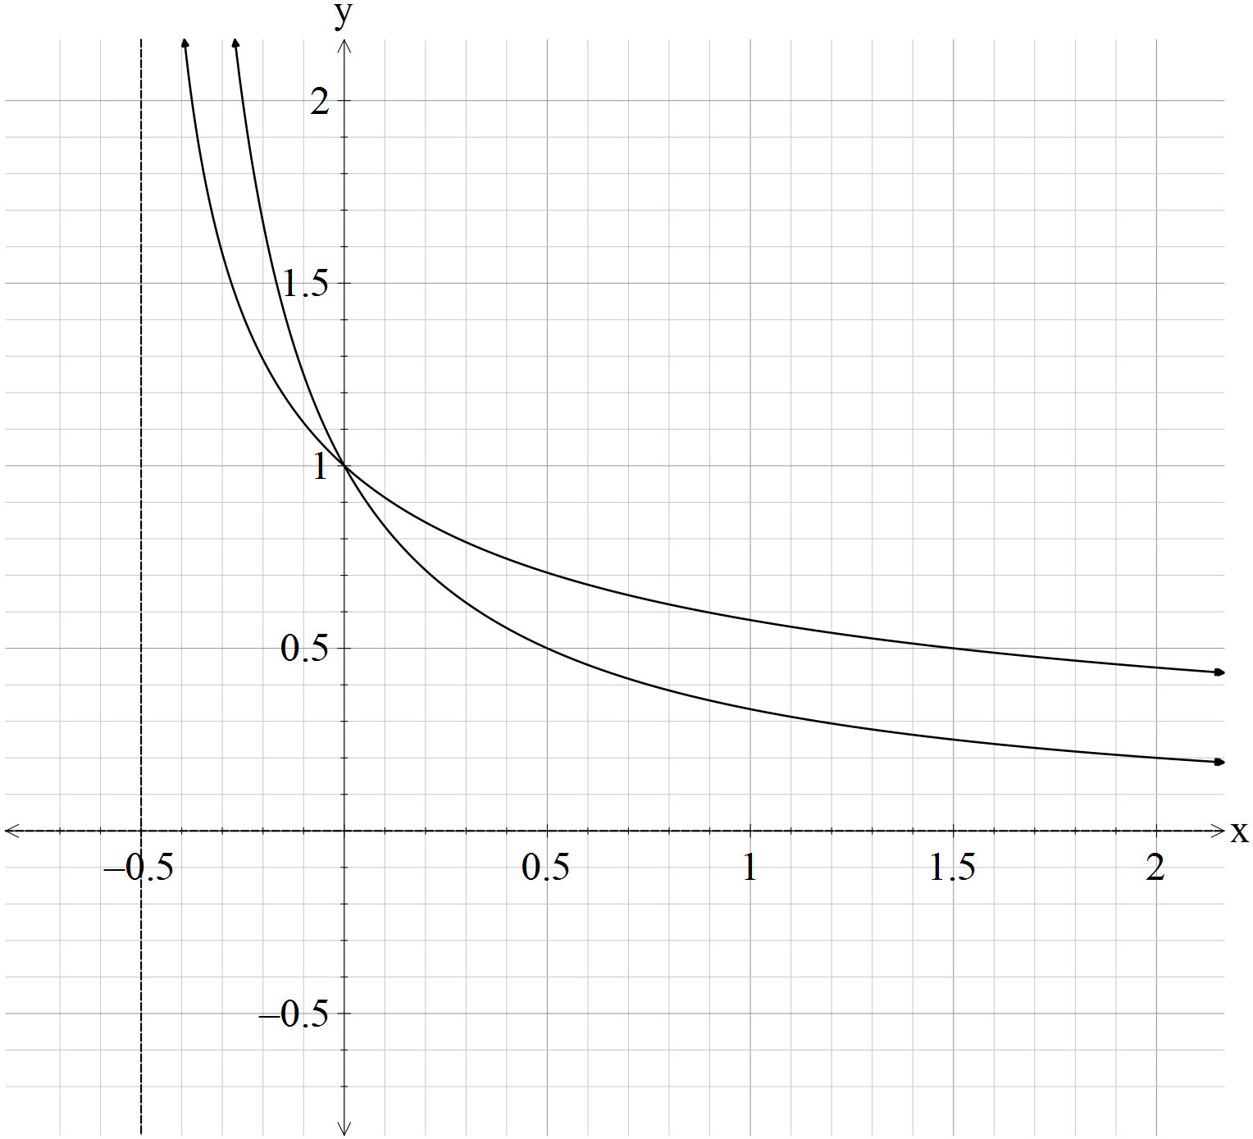Question 5 [3 & 4 = 7 marks]

$$g(x)$$
$$f(x)$$

- Find the area under the curve, in square units, for the function $f(x)=\frac{1}{2x+1}$ from $x=0$ to $x=1.$

- Find the area enclosed by the curves, in square units, of the graphs $f(x)=\frac{1}{2x+1}$ ,
$g(x)=\frac{1}{\sqrt{2x+1}}$and the line $x=1.$

Question 6 [2 marks]
Find $\frac{d}{dx}\left(x^{2}e^{x}\right)$ and use your answer to evaluate $\int{4xe^{x}\left(x+2\right)dx}.$

Question 7 [5 marks]
The region bounded by the lines $x=k$ and $x=1$ and the curve $y^{2}=4x^{3}-4x$ is rotated about the
x-axis 180$°$. The volume formed is $9π$. Determine the value of $k$ where $k$ is a positive integer.
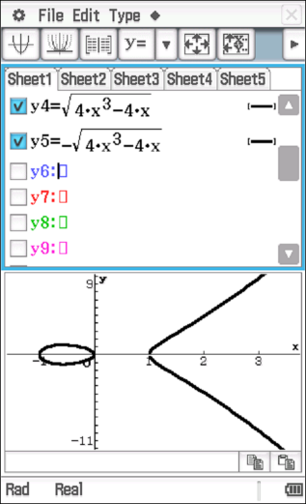

Mathematics Specialist
Test 4 2017

Integration Techniques &
Applications of Integral Calculus

NAME: _______________________________________________ TEACHER: Mrs Da Cruz

Resource Rich Section

11 marks
15 minutes

One unfolded A4 page of notes, SCSA formulae booklet and ClassPad calculator permitted

Question 8 [1, 1 & 2 = 4 marks]
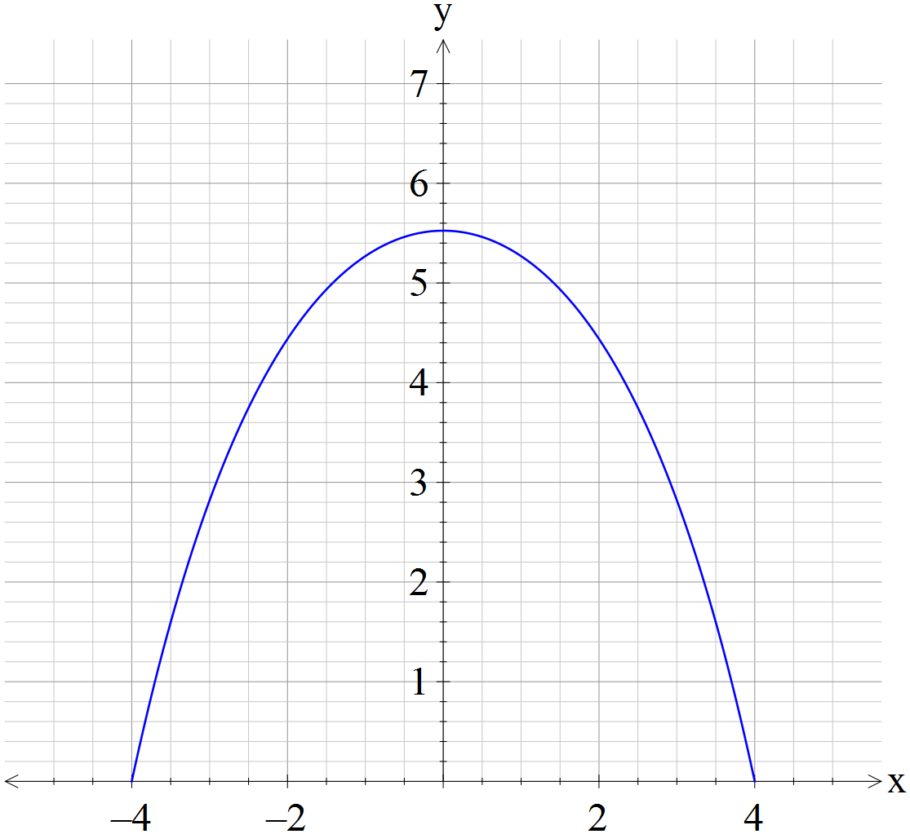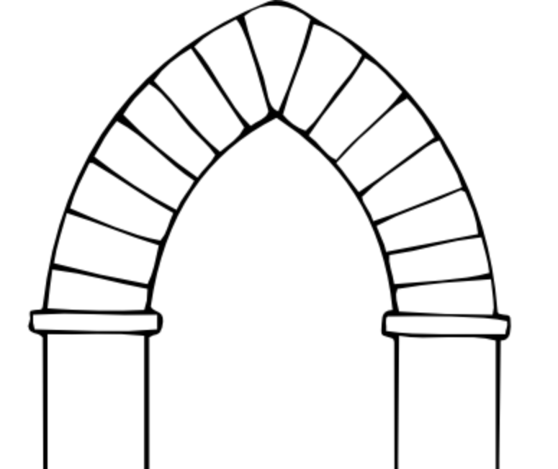

The upper component of an archway is designed to bear the load of the wall above and around it. For this, the best shape is a catenary. A catenary is the name given to the curve formed by two simple exponential terms added together. The equation of the upper arch is .
The x-intercepts of the catenary are (−4, 0) and (4, 0).
a Use this information to determine the exact value of c.

Paint has to be applied to the area under the catenary curve.
b State a definite integral that will find the area of paint required.

c Calculate the exact area to be painted, giving your answer with positive indices.

Question 9 [2 marks]
Use a suitable definite integral to find the exact volume, in cubic units, that is formed by rotating about the x-axis the following curves between the limits shown.
y = $x^{3}$, from x = 1 and x = 3.

Question 10 [3 marks]

Use a suitable definite integral to find the exact volume, in cubic units, that is formed by rotating about the y-axis the following curves between the limits shown.
, from y = 0 and y = 1.

Question 10 [2 marks]

Use a suitable definite integral to find the exact volume, in cubic units, that is formed by rotating the shaded area about the y-axis.
